Multiple-choice section – choose the correct answer

Question 1 [9.2]

The value of x in the pair of similar triangles is:

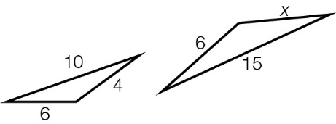

A 4 B 12 C 8 D 9

Question 2 [9.1]

Which is not a test for both congruency and similarity of triangles?

A AAA B SAS C RHS D SSS

Question 3 [9.3]

The value of x is:

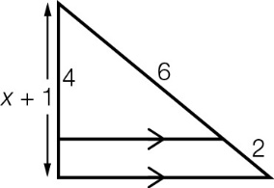

A B  C  D 

Question 4 [9.2]

Which is the incorrect statement?

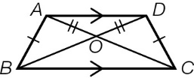

A ≡ B  ∼

C  D ≡

Question 5 [9.6] [10A]

In terms of β, θ is:

A  B  C  D 

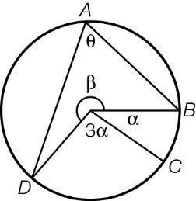

Question 6 [9.6] [10A]

Choose the correct statement.

A  B  C  D 

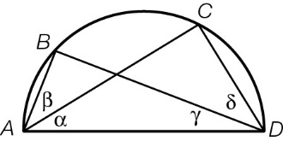

Question 7 [9.1]

 ∼with ,

, and .  
The value of a is:

A 2 B 1 C 5 D 3

Question 8 [9.6] [10A]

The value of α is:

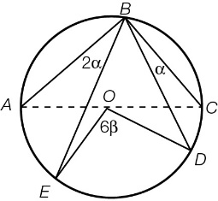

A  B  C  D 

Multiple-choice results: ___ / 8

Short answer section

Question 9 2 marks [9.6] [10A]

Use words from the list below to complete the following sentences.

arc equidistant sector of a circle chord major arc

angle at the centre subtend segment angle in a semicircle

(a) Each point on a circle is ___________________ from the centre of the circle.

(b) A straight line that connects any two points on a circle is a ___________.

Question 10 2 marks [9.6] [10A]

Explain the term ‘subtend’ in relation to an arc of a circle.

Question 11 4 marks [9.4]

Calculate the values of x and y if the pair of triangles shown are similar. Round your answers to the nearest whole number.

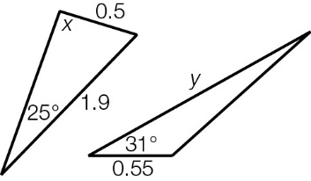

Question 12 4 marks [9.3]

An isosceles triangle ABC where AB = AC is cut to create two triangles ABH and ACH, and where AH bisects  Prove that:

(a) ≡

(b) AH is the perpendicular bisector of BC.

Question 13 3 marks [9.1, 9.2, 9.4]

 ∼and 

Calculate the lengths of AC and XY if XZ = 60 and AB = 15.

Question 14 4 marks [9.3]

(a) Prove that   is congruent to 

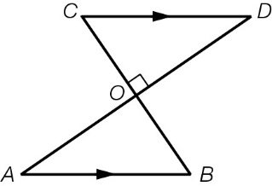

(b) Prove that BC is the perpendicular bisector of AD if AD is the perpendicular bisector of BC.

Question 15 4 marks [9.3, 9.6]

Point G is the centre of the larger semicircle and the radius of the smaller semicircle is r.

Use the properties of similar triangles to show that d = 2c.

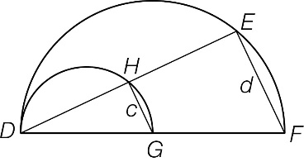

Question 16 4 marks [9.3]

ABEF is a parallelogram. C is the midpoint of BE.

Prove that E is the midpoint of DF.

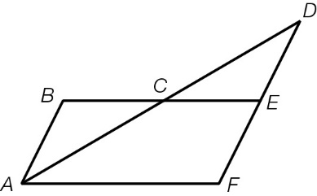

Question 17 3 marks [9.3]

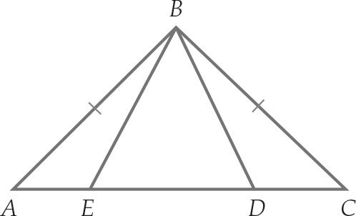

Show that when 

Question 18 4 marks [9.6] [10A]

Point O is the centre of the circle. Show that:

(a) 

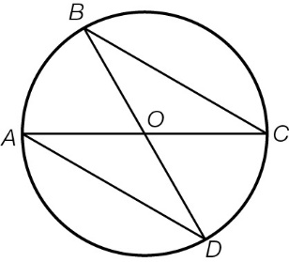

(b) 

Question 19 4 marks [9.6] [10A]

(a) Prove that .

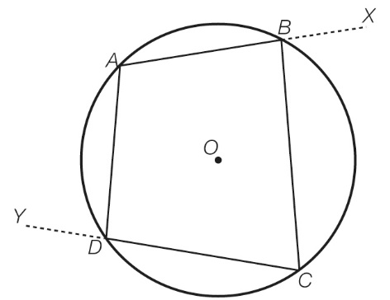

(b) Extend your result to part (a) to show that 

Short answer results: ___ / 38

Extended answer section

Question 20 5 marks [9.5]

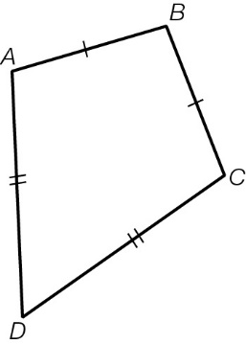

A special type of quadrilateral is shown.

(a) What is the name of this type of quadrilateral?

(b) List the equal sides.

(c) List the equal angles.

(d) State the properties of the diagonals of this shape.

(e) These two diagonals divide the figure into four triangles. Are all four of these triangles congruent?

Question 21 5 marks [9.2]

(a) Prove that for the similar triangles shown, if  then .

(b) (i) Find the value of c when a = b.

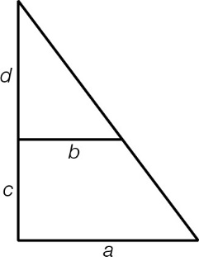

(ii) What does this mean about the triangles?

(c) Prove that if a = 2b, then c = d.

Question 22 6 marks [9.2, 9.4]

(a) Show that is similar to.

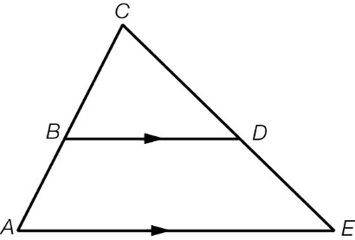

(b) Prove that for AB = kBC, .

(c) A line is drawn from D to a point M on AE so that DM BA.  
Prove that M will be the midpoint of AE when .

Question 23 5 marks [9.3, 9.4, 9.6] [10A]

O is the centre of the outer circle. The centre of the inner circle lies on the line AD.  
EF is drawn parallel to AC.

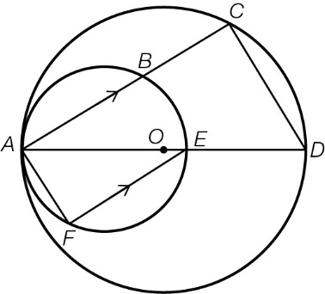

(a) Prove that  is similar to .

(b) If B is the midpoint of AC, show that 2 × BE = CD.

(c) If E and O are coincident (E is the same point as O)>  
Show that, by extending FE to meet CD at G, FG is the perpendicular bisector of CD.

Question 24 10 marks [9.1, 9.3, 9.5, 9.6, 9.7] [10A]

A circle with centre O has a quadrilateral drawn connecting points A, C, D, E on the circumference such that OA is perpendicular to CE

BF is drawn parallel to CE, cutting CA at I, OA at H, and EA at G

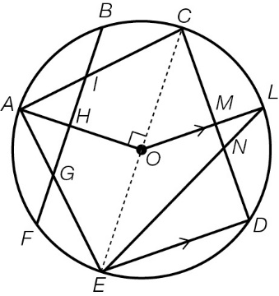

(a) Prove that .

(b) Prove that EL bisects .

(c) Prove that .

(d) For the quadrilateral ACMO, show that = 135°.

(e) Prove that  is similar to .

Question 25 5 marks [9.3]

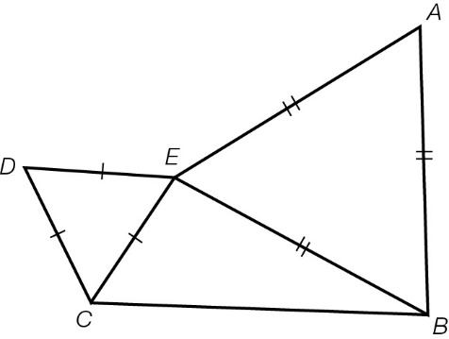

 and are different-sized equilateral triangles.

(a) Show that .

(b) Show that .

(c) Hence, show that BD = AC.

Question 26 6 marks [9.3]

 is an isosceles triangle, where AB = BC and D is the midpoint of AC.

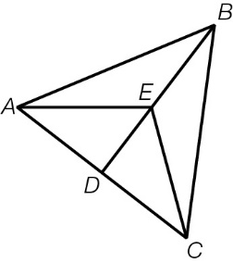

(a) Prove that .

(b) Prove that .

(c) Prove that .

Question 27 8 marks [9.1, 9.3, 9.5, 9.6, 9.7] [10A]

In the diagram, H is the midpoint of AD.

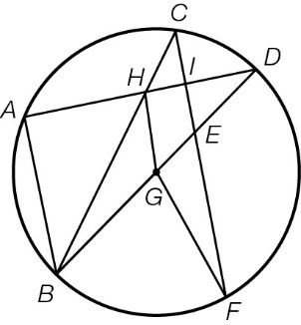

(a) Show that  is similar to .

(b) Calculate the value of HG when AB = 18 cm.

(c) If and , find ?

(d) For the quadrilateral EGHI, show that the sum of  and is a straight angle.

Question 28 9 marks [9.2, 9.3, 9.5]

ABDE is a parallelogram. Diagonals AD and BE intersect at point H. EC, drawn from E to BD, intersects the diagonal AD at I. CF is a line drawn from C to AE through H. BF intersects diagonal AD at G.

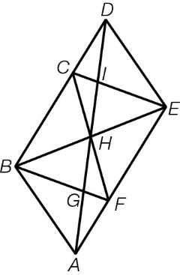

(a) Prove that ≡

(b) Show that BCEF is a parallelogram.

(c) Find three angles equal to .

(d) If FCAB, show that:

(i)  is similar to 

(ii) C is the midpoint of BD.

Extended answer results: ___ / 59

TOTAL test results: ___ / 105